Israel-Palestine conflict
Before the fall of the Ottoman empire, Muslims, Christians and some Jews lived cohesively in the area that we know of today as Israel and Palestine. The demise of the Ottoman empire resulted in the formation of British Palestine. The British government encouraged migration, resulting in the quadrupling of the Jewish population from 1880 to 1910
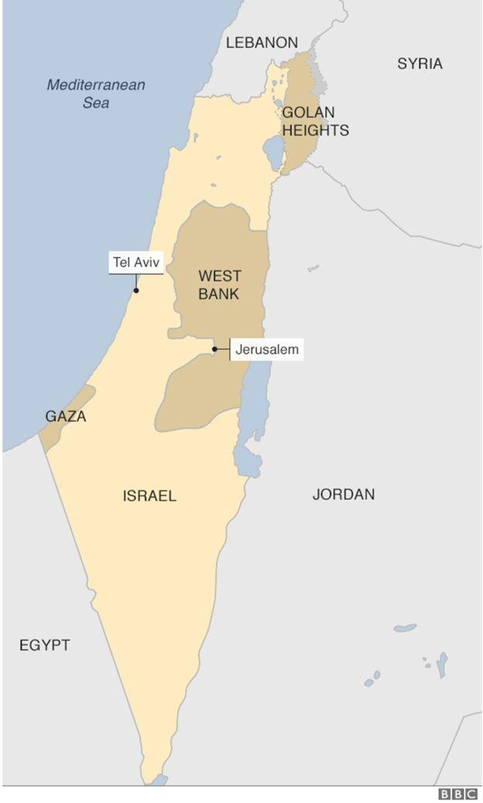
Migration increased due to the Holocaust, causing tension to rise between the Arabs and Jews. In 1947 the UN devised a plan to divide British Palestine into two states: Israel for Jews and Palestine for Arabs; with Jerusalem recognised as an international zone in order to cater for the vast cultural claims to the city. The Arabs saw this as European colonialism, resulting in the Arab-Israeli war 1948-1949. Israel won, extending their borders further than the UN agreed territory, leaving the West Bank occupied by Jordan and Gaza under Egyptian control.

Israel gained even more territory in the Six Day War 1967.They took the Syrian Golan, the Jordanian West Bank, Egyptian Gaza and the Sinai Peninsula. The Sinai was later given back to Egypt following the Camp David Agreement in 1978. The Arab backlash to the peace agreement led to the assassination of the Egyptian prime minister, Anwar el Sadat. The conflict continued in Gaza and the West Bank, with the Palestinian liberation organization fighting through terrorist means.

The Israeli government advocated Jewish settlers to move into Palestinian areas, assisting them with armed forces to help remove Palestinians from their own land. This made the Palestinian hope for their own state more difficult to achieve as the once clear geographical boundaries had been blurred by Jewish migration in the West Bank.

The conflict escalated in 1897-1993 in the first intifada (the Arabic word for protest) where protests and boycotts turned into violence resulting in the death of 1000 Palestinians. Resulting in the formation of Hamas in Gaza, a violent extremist group dedicated to the destruction of Israel in the plight of Palestinians, which are still in power today. Hamas demonstrated opposition to the Oslo Accords of 1993 through suicide bombings. The Oslo accords were Israel’s attempt to ease the conflict by allowing certain areas to be governed under Palestinian authority. The opposition wasn’t just on the Arab side, the rise of the far right Israelis resulted in further frustration and led to the assassination of the Israeli prime minister Rabin.

The troubles have since been ongoing with the second intifada in 2000-2005, where 3200 Palestinians and 100 Israelis died. The conflict led to the Israeli government building a wall to control the movement of Palestinians. But it is not only in Israel where tensions are high. Since the Israeli withdrawal from Gaza, Hamas has split from the Palestinian authority, creating a civil war and dividing the Gaza from the West Bank.
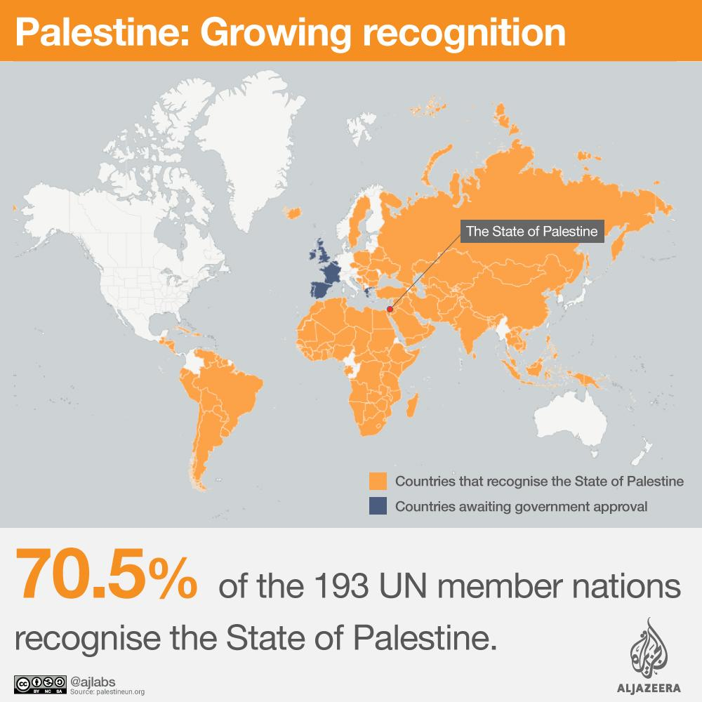
The Israeli government has caused humanitarian issues not just through direct killings of Palestinians during conflict, but through further annexation of Palestinian settlement. The settling of Jewish people in areas like the West Bank has resulted in a refugee crisis. Of the 7.2 million Palestinian refugees, 4.3 million of them are from the displacement caused back in 1948; thus indicating clearly that the issue hasn’t been solved as the number of refugees is ever on the rise

As with any refugee crisis, the countries around the state are influenced: 37.7% live in the West Bank and Gaza Strip; 15% live in almost equal numbers in Syria and Lebanon; 3% live in UNRWA’s 59 refugee camps throughout the West Bank and Gaza Strip, Jordan, Syria and Lebanon and 355,000 internally displaced Palestinians reside in present-day Israel

The Israeli government appears to suggest that they will further exacerbate the issue, following the Prime Minister’s recent declaration that he will annex the Jordan valley. This is further supported by Israeli property markets which advertise new developments in areas of Palestinian domain. It also doesn’t seem outside the nature of the Israeli government to pursue this claim as recent events have shown their efforts in the demolition of Palestinian homes in Eastern Jerusalem.

There have been various attempts, through treaties and agreements, to resolve the issue at hand. It is important to acknowledge the UN Relief Works Agency for Palestine refugees in the near east (UNRWA) who work in and out of refugee camps, trying to fulfil their human development goals which include education, healthcare, decent standards of living and the insurance of Palestinian human rights.

Community level schemes to combat the tensions in Israel have also been initiated: for example summer camp integration schemes to unite Israelis and Palestinian children amongst the current political climate. Thus it is worth thinking about what can be done on a local level to reduce communal tensions between the two groups and encourage a thaw in relations as a prevention of further conflict.

The US released a 'Peace to Prosperity’ plan in June 2019, which was Trump’s attempt to resolve the economic problems and poverty amongst Palestinians. The plan involved the investment of $50 billion for business projects, infrastructure and a travel corridor between the West Bank and Gaza, with the prediction that poverty will be reduced by half and the GDP of Palestine will be doubled. The Arab response was hostile as the document didn’t address Palestine as a state but referred to it as a society. Thus the Arab states argued they will not accept any economic solutions until a political solution is established first.

Points to consider
- What can be done to reduce the animosity between the Palestinians and Israelis?
- Should the UN intervene in the conflict?
- How can the Israeli government be persuaded to not annex?
- Should Palestine be declared as a state?
- What can be done to help the refugees?
- Is the Israeli wall a productive solution?

Useful links
https://www.unrwa.org/who-we-are/human-development-goals
https://www.vox.com/2018/11/20/18079996/israel-palestine-conflict-guide-explainer
https://www.bbc.co.uk/newsround/20436092
https://www.aljazeera.com/topics/subjects/israelipalestinian-conflict.html
https://www.youtube.com/watch?v=1wo2TLlMhiw

